57th Annual
WASHINGTON STATE SENIOR CHAMPIONSHIPS
Hosted by Central Washington USBC
(Bowlers Age 50 and Over)
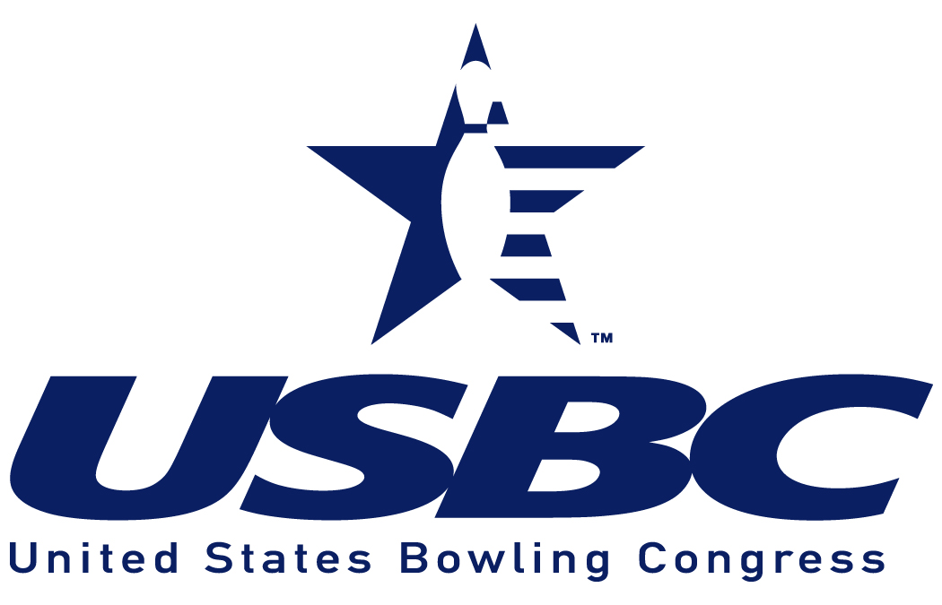

USBC Certified

NOB HILL BOWLING CENTER
3807 W Nob Hill Blvd Yakima, WA

October 4 – 5 and 11 - 12, 2025
-
Saturday: 9:00 a.m. and 1:00 p.m. Sunday: 9:00 a.m. and 1:00 p.m.

Specify  O or W | Open (O) or Women’s (W) SINGLES - $40.00 | 2024-25  Average | USBC Card #  required | All events  $15 | Age | 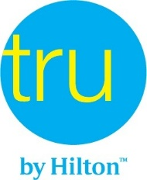  2424 West Nob Hill Blvd  Yakima, WA 98902  (509) 517-3300  Mention WSUSBC when booking
 | 1.
 | 2.
 | 1.
 | 2.
Specify  O or W | Open (O) or Women’s (W) DOUBLES - $80.00 | 2024-25  Average | USBC Card #  required | All events  $15 | Age
 | 1.
 | 2.
 | 1.
 | 2.
TEAM - OPEN  $160.00 |  | 2024-25  Average | USBC Card #  required | Age | I CERTIFY SUBMITTED INFORMATION TO BE CORRECT
(1) | 1. |  |  |  | Team Name:
(1) | 2. |  |  |  | Captain’s Name:
 | 3. |  |  |  | Signature:
 | 4.
 |  |  |  |  | Address:
(2) | 1. |  |  |  | City:
(2) | 2. |  |  |  | State:
 | 3. |  |  |  | Zip:
 | 4.. |  |  |  | Phone:
 | Bowl any event in any squad. |  |  |  | E-mail:

Specify Date & Time Preferred

Singles – Open: TEAM (1) _____
Singles – Women: TEAM (2) _____
Doubles – Open: _ TEAM (3) __________________________________
Doubles – Women: _ TEAM (4) __________________________________

Washington State Senior Championship Tournament Rules

- Doubles will be bowled in one division. Singles will be bowled in two divisions. Division A includes bowlers 65 years of age and over; Division B, bowlers 50 to 64 years of age. Date for determining Division is as of the date of bowling. Bowlers under 50 years of age are not eligible to enter; except a bowler 50 years of age or over may enter with his or her spouse in Mixed Doubles regardless of the age of the spouse.
- All bowlers must be members of USBC bowling in leagues certified through local associations affiliated with the state of Washington. Bowlers from Oregon, Idaho and Canada USBC’s are welcome to participate.
- Entrants will use their highest USBC or CTF certified league yearbook or association average based on the 2024-2025 season with a minimum of 21 games, including summer league average. If the bowler has no qualifying average 2024-25, they may enter using their highest 2025-2026 average for 12 or more games at the time of bowling. USBC Rules 319(d) and 319(e) apply in this tournament, all others bowl scratch. As per USBC Rule 319a (3), it shall be each bowler’s responsibility to verify the accuracy of his/her average, whether originally submitted by the bowler, the team captain, or others. Average verification must be submitted prior to bowling if a bowler’s confirmation has an asterisk next to his/her name. Failure to use the proper average or to make correction prior to, or before completion of the first game of any event shall disqualify score if submitted average is lower than actual average, or base prize winnings on submitted average if higher. Entrants without a verified average will automatically be assigned an average of 230. USBC Rule 319a (2) does not apply.
- All entrants having only a SPORT LEAGUE or Challenge average must report this fact to the Tournament Manager. All Sport & Challenge League-only averages will be adjusted using the USBC recommended scale Playing Rules Manual, Rule 203. Bowlers with Sport League, Challenge and a regular average must use the higher average.
- Handicap will be 90% of 230. If no average, a score of 230 will be assigned.
- Entry fee: $40.00 per person/per event. Prize fund $20.00; lineage and expense fee $20.00. Prize fee will be returned 100% in each event or division of the event. Optional all events of $15 is required if you want to have a chance to win a paid spot into the 2026 Senior National Tournament. Location to be announced and dates to be announced.
- Bowlers may bowl an unlimited number of times in the Open and Women’s singles/doubles events, but may cash only once with the same partner. Cash only once in Open/Women’s singles. Bowlers may bowl team multiple times, must change 2 bowlers. First time in Open/Women’s singles/doubles counts for All Events per USBC Rule 315.
- Trophies or plaques will be awarded to all champions. In the event of a tie for the championship, co-champions will be declared with duplicate prizes and awards. Prize payout 1 for every six entries, or major portion thereof.
- Closing date for all entries is 60 minutes prior to start of final squad (space available) 1:00 p.m. on Sunday, October 12, 2025.
- $35.00 will be charged for any checks returned by banks, credit unions, etc. Plus any bank fees.

Qualify for National Senior Championships
The $15 All Events fee must be paid in order to qualify for the high handicap all-events score, (3 games singles and 3 games doubles) in the following age divisions for both Open and Women participants (Super Senior: 75 and up; Division A: 70 to 74 years; Division B: 65 to 69 years; Division C: 60 to 64 years; Division D: 55 to 59 years; Division E: 50 to 54 years) will qualify winners to enter the National Senior Championships in 2026. Each will receive a paid entry into the championships. The entry is not transferable. Team scores do not count for All Events. In the event of a tie, the winner will be determined by the high single game with handicap in the all-events competition, if a tie still exists, the second highest game with handicap or the third, etc., will be used to determine the winner. The age of bowlers as of July 1 will decide the bowler’s division in the event year of National Championships.

CHECKS PAYABLE TO: WSUSBC
MAIL COMPLETED ENTRY FORM AND FEES TO:

Brooke Johnson
Association Manager
5134 Stadium Ln SE G202
Olympia WA 98501
Email: WSUSBC@comcast.net
Phone: 360-970-7994

