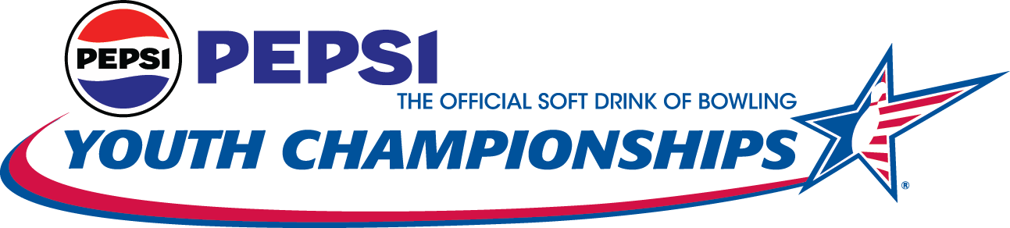
Triangle Bowl
700 Triangle Center
Longview, WA 98632
360-425-4060
E-mail address: bowwlerrdiva@gmail.com

2025 WASHINGTON STATE USBC PEPSI YOUTH CHAMPIONSHIPS
STATE FINALS RESERVATION FORM

Please return this form or email bowwlerrdiva@gmail.com if you cannot bowl the finals so that we can contact an alternate.

BOWLER NAME ____________________________________________________ Average as of March 1, 2025: _______
(Required)

PARENTS NAME:___________________________________________ADDRESS:________________________________
BOWLER ADDRESS ___________________________________ CITY ___________________ ZIP____________

PHONE (____)____________________ E-MAIL ADDRESS: (required) _____________________________

COACH /League Secretary_____________________________ Date of Birth: ______________Age (8/1/2023): _______

(Required)
Name of Bowling Center or Travel League where you bowled in: _____________________________________________

Please indicate division in which you competed at Sectional Level: Must stay in same division as qualified in at Sectionals.

Must Circle One: U8 - U10 - U12 - U15 - U18 Required: Boy___ Girl____ USBC#_____________
(Required)
[ ] U8, U10, U12, U15, & U18: I will be available to participate in the Washington State USBC Pepsi Youth Championship State Finals at Triangle Bowl April 26 & 27, 2025. I understand that I must be able to participate for the two days (second day is only if you make the cut from Saturday) in order to be eligible for the scholarship awards. My entry fees of $ 50.00 for U8, U10 $65.00 for, U12, U15, U18 is enclosed with this entry form and must be paid at time of

registration.
There will be a max of 72 bowlers per squad
Please select which squad you prefer: Saturday, April 26, 2025 @9am____ or 1:30pm____
QR Code at the left will take you to the Pepsi State to register online
If the squad you select is full, you will be assigned the other squad time.
Top 8 Max – match play will begin on Sunday, April 27, 2025 @9am
[ ] I will NOT be available to participate in the Washington State Pepsi finals on April 26 & 27, 2025. I understand that my spot will be offered to the next qualifier.
I have read and agree to compete under the rules available online at www.wsusbc.net including the dress code.
____________________________________ ____________________
Bowlers’ Signature Date
Cassandra Chalmers, Tournament Director PO Box 141, Silver Creek WA 98585 (360) 790-4090
Make checks payable to WSUSBC. Entries MUST be postmarked and paid for by April 9, 2025
IN ORDER TO ACCEPT THIS FORM, THE FOLLOWING MUST BE COMPLETED:
- Reservation form must be filled out completely, USBC# must be on entry form to be eligible.
- Reservation form must have entry fee included. ($50) ($65) PLEASE READ
- Entry MUST be to the Tournament Director by April 10, 2025, with a post mark date of April 7, 2025.
- Bowlers must check in with USBC card & be in dress code compliance at least 30 minutes prior to scheduled squad.
INCOMPLETE ENTRIES RECEIVED MAY JEOPARDIZE YOUR ABILITY TO PARTICIPATE IN THE FINALS.
Host Hotels: Quality Inn & Suites 723 7th Ave | Longview, WA 98632 – (360) 414-1000 Group: Pepsi State- $128 per night plus tax, Room Block is for April 25 & 27, 2025 - 15 rooms each night, Block closes April 18, 2025. 72 Hour Cancellation Policy.

