WSUSBC Women’s State Tournament

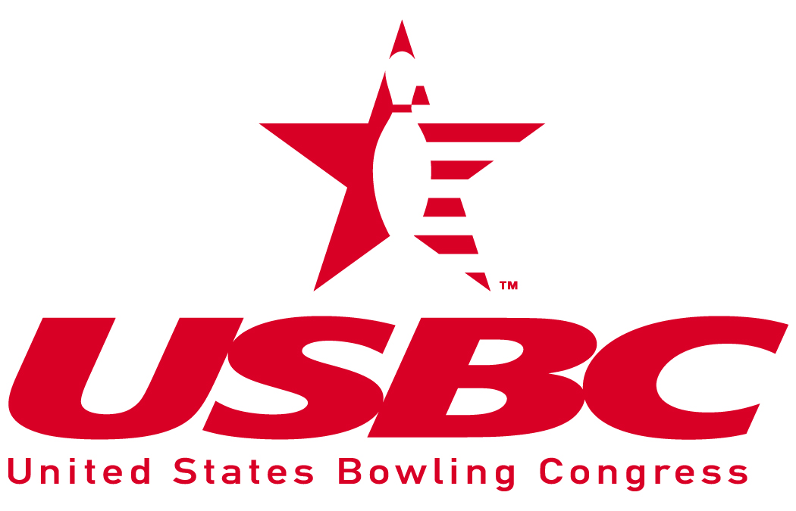
Certified by the United States Bowling Congress
Hosted by Skagit Valley USBC
May 17 – June 29, 2025 / 6 Weekends (Excluding June 14 & 15)
TOURNAMENT WILL BOWL MEMORIAL WEEKEND – MAY 24-25, 2025
Lanes will be oiled prior to each squad.
4-Person TEAM ($140.00)  Please List Bowlers in order of bowling  First Name MI Last Name | Highest  2023-24  Average  Including  Summer |  | Divisions  A-680 & Above  B-679 & Below |  | National ID  Card # |  |  | State  600  Club  $15 | Team Event:  Oak Bowl  531 SE Midway Blvd Oak Harbor, WA 98277  (360) 679-2533
1. |  |  |  |  |  |  |  |  | May 17 – June 29, 2025  Saturday: 9:00am, 12:30pm, 4:00pm  Sunday: 9:00am, 12:30pm  1st Choice:___________  2nd Choice: __________
2.
3.
4.
SINGLES ($35.00) & DOUBLES ($70.00)  First Name MI Last Name | Highest  2023-24  Average  Including Summer | Doubles Divisions  A-340 & up  B-339 & below |  | Singles Divisions  A-170 & up  B-169 & below |  | All Events ($5) |  | Doubles/Singles:  Riverside Lanes  225 Riverside Ln  Mount Vernon, WA 98273
 |  |  |  |  |  | H | S
1. |  |  |  |  |  |  |  | May 17 – June 29, 2025  Saturday 9:00 am, 1:30 pm & 5:30 pm  Sunday: 9:00 am & 1:30 pm  S/D will bowl on the same pair
2.
1.
2.
1. |  |  |  |  |  |  |  | 1st Choice:
2. |  |  |  |  |  |  |  | 2nd Choice:

Please Print Legibly  Team Name:  ____________________________________  Captain: ____________________________________  Mailing Address: ______________________________  City: ___________________ State: _______  Zip Code: _____________  Phone Number: ( ____ ) __________________  E-Mail Address: _____________________________________ |   Host Hotel  Swinomish Casino & Lodge  12885 Casino Dr, Anacortes, WA 98221  $149-169 per night plus taxes (up to 4 per room)  (855) 794-6563 and use group code WSUSBC | I hereby certify that the averages listed above and total entry fees are enclosed:  $140/Team $________ Each TEAM  $ 70/Doubles $________ Each DOUBLES  $ 35/Singles $________ Each SINGLES  OPTIONAL EVENTS  $ 5/All Events $________ Each HANDICAP  $ 5/All Events $________ Each SCRATCH  $15 - 600 Club $15________Each 600 Club  $________ TOTAL

Washington State USBC Association Women’s Tournament Rules

- All bowlers must be members of USBC certified through local associations affiliated with the state of Washington. Oregon and Idaho Associations that have reciprocal agreements do not pay an affiliate fee. All other bowlers will purchase a USBC card from the local Association.
- Entrants will use their highest USBC or CTF composite average of last 2 seasons (2023-24 or 2022-23) with 21 games or more. If the bowler has no qualifying average from those 2 seasons, then their composite average from the most recent season (2023-24) with 12 games or more will be used. If no other average is available all others will bowl scratch. As per USBC Rule 319a (4), it shall be each bowler’s responsibility to verify the accuracy of his/her average, whether originally submitted by the bowler, the team captain, or others. Average verification must be submitted prior to bowling if a bowler’s confirmation has an asterisk next to her name. Failure to use the proper average or to make correction prior to completion of the first game of any event shall disqualify score if submitted average is lower than actual average, or base prize winnings on submitted average if higher. Entrants without a verified average will automatically be assigned an average of 230. USBC Rule 319a (2) does not apply.
- Doubles will be bowled in two divisions A 340 & above & B 339 & below. Singles will be bowled in two divisions A 170 & above & B 169 & below. Team will be bowled in two divisions A 680 & above & B 679 & below.
- Reservations: Completed entry forms and fees must be received in full in the Association Manager’s office within (10) ten days or the reservation may be cancelled - without notice given. The Tournament Manager reserves the right to extend the entries if there is space available on any squad and fees are paid in full.
- Entries close 45 minutes prior to the start of current squad, space available.
- All entrants having only a SPORT LEAGUE & CHALLENGE LEAGUE average must report this fact to the Tournament Manager. All Sport League-only & Challenge League averages will be adjusted using the USBC recommended scale (2024-2025 Playing Rules Manual). Bowlers with Sport League, Challenge League and a regular average must use the higher average.
- Handicap will be 90% of 230. If no average, 230 will be assigned.
- Entry fee: $35.00 per person/per event. Prize fund will be $18.00; $13 for lineage and $4 expense fee. Prize fee will be returned 100% in each event or division of the event. Optional all events of $5. Bowlers may bowl an unlimited number of times in the singles & doubles event but cash only once in singles; you must change your doubles partner (1 in 6 payout), 1 in 12 for all events. You will have to change (2) bowlers for team. A $35.00 fee will be charged on any returned check, plus any bank fees. First time in singles, doubles & team counts for All Events per USBC Rule 315. For any prize checks that need re-printed due to being lost, ruined, or expired etc, fee of $30.00 may be charged for a stop payment.
- Changes in lineups are not allowed: rule 324a does not apply. Substitutions may be made up to (1) one hour before time of bowling. The substitute must take lineup position of the absent bowler.
- No more than (1) one professional bowler will be allowed to bowl on a 4-person Team unless they are regular members of the team and have bowled two – thirds of the league games as of the date of their scheduled appearance. Not more than one professional bowler will be permitted on a doubles team. A professional bowler is defined as a bowler who holds a membership card in the PBA or PWBA.
- Trophies or plaques will be awarded to all champions. In the event of a tie, co-champions will be declared with duplicate prizes and awards.
- The first-place winners of Team, Singles and Doubles events will receive an entry paid into the 2024-25 WSUSBC Women’s Tournament.
- The individual with the highest scratch All Events score will be awarded an entry into the 2026 WSUSBC Queens tournament. The entry is nontransferable. If the first-place winner cannot or chooses not to participate, the second place scratch all events winner will be offered the spot.
- Grand Duchess Award: The participant age 70 or over with the highest scratch series will receive the Grand Duchess award.

MAKE CHECKS PAYABLE TO: WSUSBC Association

Tyson Pawley, WSUSBC Association Manager
PO Box 7135
Spokane, WA 99207

Phone: (509) 798-4045
E-Mail: wsusbc@comcast.net

